Snapshot Replication

**1. Distributor Configuration**

* 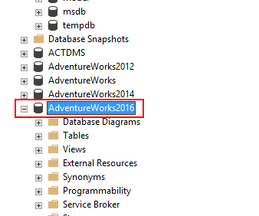Open SSMS and connect to the SQL Server Instance.
* Navigate to Object Explorer, right-click Replication, and click Configure Distribution.

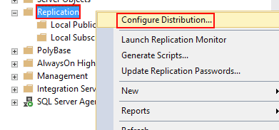

* The Configure Distribution Wizard will appear. Click Next. Leave the default settings and click Next again when you are asked to choose the server that acts as the distributor.

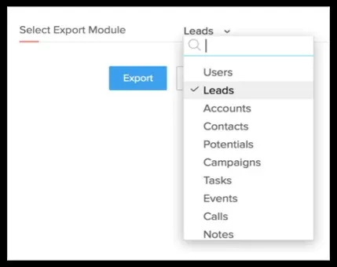

* 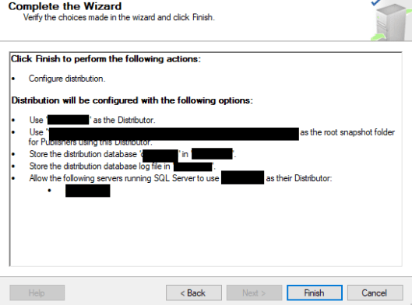Choose the storage location for your replication snapshot. This can be a folder on the server or a network share.

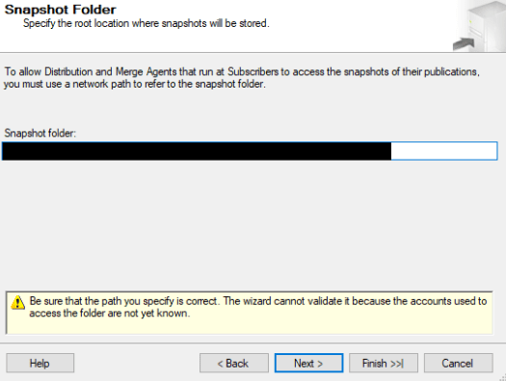

* Name your distribution database and specify locations to store the data and log files.

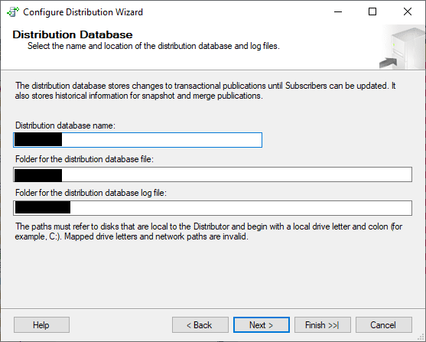

* Under Publishers, select the replication publishers that will access the distributor and select Next.
* Under Wizard Actions, select Configure distribution and click Next.

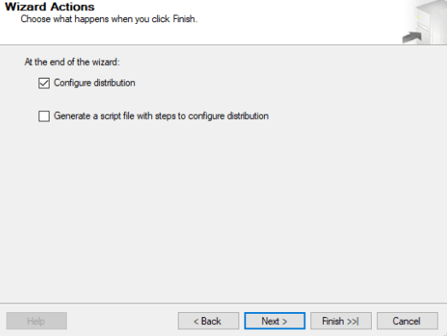

* Finally review the settings and click Finish.